# On the Discretization Methods for Partial Differential Equations

# Finite Difference Method (FDM), Finite Volume Method (FVM) , Domain Decomposition Method (DDM)

##### **Ali Anıl APAYDIN*, Caner ASLAN*, Mehmet KOCABAŞ\***

* GTU, Department of Computer Engineering

**Abstract**

This report explores the discretization methods of the Partial Differential Equations (PDE). The report includes descriptions and fundamental topics of the Finite Difference Method (FDM), Finite Volume Method (FVM) and Domain Decomposition Method (DDM).

1. Introduction

The partial differential equation we will focus on is a scalar equation that represents the transport of a substance under the influence of advection by the air flow and mixing. The transport equation is frequently written in the adjective form:

$\frac{∂T}{∂t}+\vec{u}·∇T=∇·\left(α∇T\right)$

where T is the substance transported, e.g. temperature, humidity or a pollutant concentration, $\vec{u}$ is the velocity field presumed known, and α is the diffusion coefficient and which can represent either molecular diffusion or eddy mixing.

The velocity field cannot be arbitrary and must satisfy some sort of mass conservation equation. Here we will assume the flow to be incompressible so that its mass conservation equation reduces to: $∇·\vec{u}=0$

The adjective form can be interpreted as the time evolution of the T field along characteristic lines given by $\frac{dx}{dt}=\vec{u}$. It is thus closest to a Lagrangian description of the flow where one follows individual particles. In the Eulerian frame, however, another important issue is the conservation of the tracer T for long period of times. This stems not only from physical considerations but also for the need to account for the sources and sinks of T in long calculations. It is imperative that the discretization does not introduce spurious sources (this the prime imperative in climate models for example). A slightly different form of the equation called the conservative form can be derived and forms the starting point for the derivation of finite volume methods. Multiplying the continuity equation by T, adding it to the resultant equations to the adjective form, and recalling that

$\vec{u}·∇T+T∇·\vec{u}=∇·\left(\vec{u}T\right)$

We can derive the conservative form of the transport diffusion equation:

$$\frac{∂T}{∂t}+∇·\left(\vec{u}T\right)=∇·\left(α∇T\right)$$

1. Finite Difference Method (FDM)

**A Brief History of the finite Difference Method:**

The finite difference method was invented by a Chinese scientist named Feng Kang in the late 1950’s. He proposed the finite difference method as a systematic numerical method for solving partial differential equations that are applied to the computations of dam constructions. It is speculated that the same method was also independently invented in the West, named in the West the finite element method. It is now considered that the invention of the finite difference method is a milestone of computational mathematics. [1]

**Definition and Description of the Finite Difference Methods:**

In a simplistic way, a finite difference is defined as a mathematical expression of the form $f\left(x+b\right)-f\left(x+a\right)$. If a finite difference is divided by $(b-a)$, one gets an expression like a differential quotient, except that it uses finite quantities instead of infinitesimal ones. The approximation of derivatives by finite differences plays a central role in finite difference methods for the numerical solution of partial differential equations.

In solving partial differential equations, the primary challenge is to create an equation which approximates the equation to be studied, but which is numerically stable, meaning that errors in the input data and intermediate calculations do not accumulate and cause the resulting output to be meaningless.

**Finite Difference Approximations**

The basic idea of FDM is to replace the partial derivatives by approximations obtained by Taylor expansions near the point of interests.

Forward Taylor Series Expansion;

$$f\left(x+ ∆x\right)=f\left(x\right)+f^{'}\left(x\right)∆x+\frac{f''(x){∆x}^{2}}{2!}+…$$

Backward Taylor Series Expansion;

$$f\left(x- ∆x\right)=f\left(x\right)-f^{'}\left(x\right)∆x+\frac{f^{''}\left(x\right){∆x}^{2}}{2!}-…$$

If we add these two equations and truncate after second derivative terms, we get;

$$f''\left(x\right)=\frac{f\left(x-∆x\right)-2f\left(x\right)+f(x+∆x)}{{∆x}^{2}}$$

The finite difference method applies three main difference schemes: The forward difference, the central difference, and the backward difference.

We can explain this schemes by an example:

**Diffusion Equations of One State Variable** [2]

where t is a time variable, x is a state variable, and $u(x,t)$ is an unknown function satisfying the equation.

To find well-defined solution, we need to impose the initial condition

$$u\left(x,0\right)=u_{0}\left(x\right) (2)$$

and, if $D=\left[a,b\right]x[0,∞]$, the boundary conditions

$$u\left(a,t\right)=g_{a}\left(t\right) and u\left(b,t\right)= g_{b}\left(t\right), (3)$$

where $u_{0}$, $g_{a}$, $g_{b}$, are continuous functions.

If $D=\left[-∞,∞\right]x[0,∞]$,

We need to impose the boundary conditions

$$\lim_{|x|→∞}{u\left(x,t\right)e^{-ax^{2}}=0 for any a>0 (4)}$$

(4) implies $u(x,t)$ does not grow too fast as |x| ∞.

The diffusion equation (1) with the initial condition (2) and the boundary conditions (3) is well-posed, i.e. there exists a unique solution that depends continuously on $u_{0}$, $g_{a}$, $g_{b}$.

**Grid Points:**

To find a numerical solution to equation (1) with finite difference methods, we first need to define a set of grid points in the domain D as follows:

Choose a state step size $∆x=\frac{b-a}{N}$ (N is an integer) and a time step size $∆t$, draw a set of horizontal and vertical lines across D, and get all intersection points ${(x}_{j},t_{n})$ or simply $\left(j,n\right)$

Where $x_{j}=a+j∆x, j=0…N$ and $t_{n}=n∆t, n=0, 1…$

If $D=\left[a,b\right] x [0,T]$ then choose $Δt = \frac{T}{M}$ (M is an integer) and $t_{n}=n∆t, n=0,…,M$

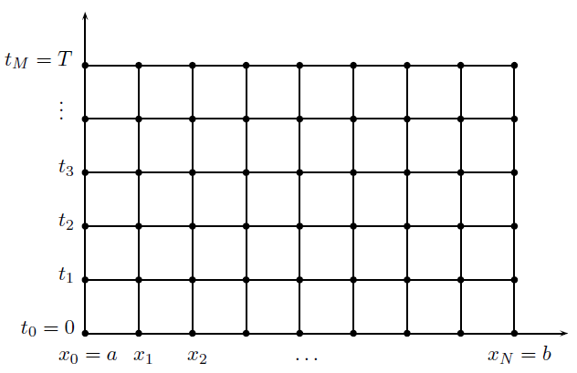

**Finite Differences:**

The partial derivatives $u_{x}∶=\frac{∂u}{∂x}$ and $u_{xx}∶=\frac{∂^{2}u}{∂^{2}x}$

are always approximated by central difference quotients, i.e.

$$u_{x}≈ \frac{u_{j+1}^{n}- u_{j-1}^{n}}{2∆x} and u_{xx}≈ \frac{u_{j+1}^{n}- {2u}_{j}^{n}+ u_{j-1}^{n}}{{\left(∆x\right)}^{2}} (5)$$

Depending on how $u_{t}$ is approximated, we have three basic schemes: explicit, implicit, and Crank–Nicolson schemes.

**Explicit Scheme**

If $u_{t}$ is approximated by a forward difference quotient

$u_{t}≈ \frac{{u_{j}}^{n+1}- u_{j}^{n}}{∆t}$ at (j, n),

then the corresponding difference equation to (1) at grid point (j, n) is

$$w_{j}^{n+1}= λw_{j+1}^{n}+\left(1+2λ\right)w_{j}^{n}+ {λw}_{j-1}^{n}, (6)$$

where

$$λ := c^{2}\frac{∆t}{{(∆x)}^{2}}$$

The initial condition is $w_{j}^{0}= u_{0}\left(x_{j}\right), j=0,… , N,$ and the boundary conditions are $w_{0}^{n}= g_{a}\left(t_{n}\right)$ and

$$w_{N}^{n}= g_{b}\left(t_{n}\right), n=0, 1, …$$

The difference equations (6), j = 1, …, N – 1, can be solved explicitly.

**Implicit Scheme**

If $u_{t}$ is approximated by a backward difference quotient

$u_{t}≈ \frac{{u_{j}}^{n+1}- u_{j}^{n}}{∆t} at (j, n+1),$

then the corresponding difference equation to (1) at grid point (j, n+1) is

$$-λw_{j+1}^{n+1}+\left(1+2λ\right)w_{j}^{n+1}- {λw}_{j+1}^{n+1}= w_{j}^{n} . (7)$$

The difference equations (7), j = 1,2 … N – 1, together with the initial and boundary conditions as before, can be solved the Crout algorithm or the SOR algorithm.

Explicit Method

$$\frac{{w_{j}}^{n+1}- w_{j}^{n}}{∆t}=c^{2}\frac{w_{j-1}^{n}- {2w}_{j}^{n}+ w_{j+1}^{n}}{{(∆x)}^{2}}$$

Letting $λ := c^{2}\frac{∆t}{{(∆x)}^{2}}$ gives (6).

Implicit Method

$$\frac{{w_{j}}^{n+1}- w_{j}^{n}}{∆t}=c^{2}\frac{w_{j-1}^{n+1}- {2w}_{j}^{n+1}+ w_{j+1}^{n+1}}{{(∆x)}^{2}}$$

Letting $λ := c^{2}\frac{∆t}{{(∆x)}^{2}}$ gives (7).

In matrix form

$\left(\begin{aligned}\begin{matrix}1+2λ & -λ & & \\ -λ & 1+2λ & -λ & \\ & ⋱ & ⋱ & \\ & & -λ & 1+2λ\end{matrix} \\ \end{aligned}\right)w = b.$

The matrix is tridiagonal and diagonally dominant. $⟹Crout/ SOR$.

**Crank–Nicolson Scheme.**

The Crank-Nicolson scheme is the average of the explicit scheme at (j, n) and the implicit scheme at

(j, n+1).

The resulting difference equation is

$$-\frac{λ}{2}w_{j-1}^{n+1}+\left(1+λ\right)w_{j}^{n+1}- {\frac{λ}{2}w}_{j+1}^{n+1}= {\frac{λ}{2}w}_{j-1}^{n}+\left(1-λ\right)w_{j}^{n} + {\frac{λ}{2}w}_{j+1}^{n}. (8)$$

The difference equations (8), j = 1, .. N – 1, together with the initial and boundary conditions as before, can be solved using Crout algorithm or SOR algorithm.

Crank-Nicolson

$\frac{1}{2}\left[\left(†\right)+\left(‡\right)\right]$

$$\frac{{w_{j}}^{n+1}- w_{j}^{n}}{∆t}={\frac{1}{2}c}^{2}\frac{w_{j-1}^{n}- {2w}_{j}^{n}+ w_{j+1}^{n}}{{(∆x)}^{2}}+ {\frac{1}{2}c}^{2}\frac{w_{j-1}^{n+1}- {2w}_{j}^{n+1}+ w_{j+1}^{n+1}}{{(∆x)}^{2}}$$

Letting $μ := \frac{1}{2}c^{2}\frac{∆t}{{(∆x)}^{2}}= \frac{λ}{2}$

$$-μw_{j+1}^{n+1}+\left(1+2μ\right)w_{j}^{n+1}- {μw}_{j-1}^{n+1}= {\hat{w}}_{j}^{n+1}$$

and ${\hat{w}}_{j}^{n+1}=μw_{j+1}^{n}+\left(1-2μ\right)w_{j}^{n}+ {μw}_{j-1}^{n}$.

This can be interpreted as

- predictor (explicit method)

- corrector (implicit method)

**Local Truncation Errors**

These are measures of the error by which the exact solution of a differential equation does not satisfy the difference equation at the grid points and are obtained by substituting the exact solution of the continuous problem into the numerical scheme.

A necessary condition for the convergence of the numerical solutions to the continuous solution is that the local truncation error tends to zero as the step size goes to zero. In this case the method is said to be consistent.

It can be shown that all three methods are consistent.

The explicit and implicit schemes have local truncation errors $O\left(Δt,{Δx}^{2}\right),$ while that of the Crank–Nicolson scheme is $O\left(\left({Δt}^{2}\right),\left({Δx}^{2}\right)\right)$.

For the explicit scheme we get for the LTE at (j, n)

$$E_{j}^{n}=\frac{u\left(x_{j},t_{n+1}\right)-u\left(x_{j},t_{n}\right)}{Δt}- c^{2}\frac{u\left(x_{j-1},t_{n}\right)-2u\left(x_{j},t_{n}\right)+ u\left(x_{j+1},t_{n}\right)}{{(Δx)}^{2}}$$

With the help of Taylor expansion at $\left(x_{j}, t_{n}\right)$ we find that

$$\frac{u\left(x_{j},t_{n+1}\right)-u\left(x_{j},t_{n}\right)}{Δt}=u_{t}\left(x_{j},t_{n}\right)+O\left(Δt\right)$$

$$\frac{u\left(x_{j-1},t_{n}\right)-2u\left(x_{j},t_{n}\right)+u\left(x_{j+1},t_{n}\right)}{{(Δx)}^{2}}=u_{xz}\left(x_{j},t_{n}\right)+O\left({(Δx)}^{2}\right)$$

Hence

$$E_{j}^{n}=\underset{0}{\underbrace{u_{t}\left(x_{j},t_{n}\right)-c^{2}u_{xx}\left(x_{j},t_{n}\right)}}+O\left(Δt\right)+O\left({(Δx)}^{2}\right)$$

**Numerical Stability** [3]

There is complicated analysis on the referenced article, main idea behind this section is comparison between the approximated solution and the exact solution.

To make it simple, we can define two terms: Convergence and Stability of the solution.

Convergence: The solutions converge means that the solution obtained using the finite difference method approaches the true solution as the steps $∆x$ and $∆t$ approach zero.

Stability: An algorithm is stable if the errors at each stage of the computation are not magnified as the computation progresses.

For example, $T(x , t+k )$ can be computed directly using:

$$T\left(x , t+k \right)=λT\left(x-h, t\right)+\left(1-2λ\right)T\left(x,t\right)+λT(x+h,t)$$

* It can be unstable (errors are magnified)

To guarantee stability, $\left(1-2λ\right)≥0 ,⇒ λ≤ \frac{1}{2} ⇒k ≤ \frac{h^{2}}{2}$

This means k is much smaller than h and this makes it slow.

**Observations so far**

There was really complex mathematic formulas about approximations, implicit, explicit and Crank-Nicolson schemes.

We have put algorithm implementations [4] of steady-state heat equation on GitHub page, the implementations are easier to understand than formulas. And their computations are at most $O(n^{2})$.

And there is also another paper about Parallel Numerical Algorithms. [5]

Parallel computational complexity: O (${n^{2}}/p$)

Parallel communication complexity: O(n)

If we do matrix multiplication faster we can reduce the complexity of differential equations

1. Finite Volume Method (FVM)

The finite volume method is a discretization method which is well suited for the numerical simulation of various types (elliptic, parabolic or hyperbolic, for instance) of conservation laws; it has been extensively used in several engineering fields, such as fluid mechanics, heat and mass transfer or petroleum engineering. Some of the important features of the finite volume method are like those of the finite element  
method, it may be used on arbitrary geometries, using structured or unstructured meshes, and it leads to robust schemes. [6]

The finite volume method is locally conservative because it is based on a “balance” approach: a local balance is written on each discretization cell which is often called “control volume”; by the divergence formula, an integral formulation of the fluxes over the boundary of the control volume is then obtained. The fluxes on the boundary are discretized with respect to the discrete unknowns. [7]

1. Cell-Centred Finite Volume Method [8] [9]

Let $T$ be a triangular or Cartesian grid of $Ω$. We choose the finite dimensional space

$V=v∈L^{2}\left(Ω\right):v∨τisconstantforallt∈T$

Then $dimV=NT$, the number of elements of $T$. We also choose $B=T$. To complete the discretization, we need to assign the boundary flux of each element.

This can be done in a finite difference fashion. For example, for an interior side $e$ (an edge in 2-D and a face in 3-D) shared by two elements $τ_{1}$ and $τ2$, we can define

$$∇_{h}u_{h}·n_{e}:=\frac{u_{h}∨τ_{2}-u_{h}∨τ_{1}}{c_{τ_{2}}-c_{τ_{1}}},$$

where the normal vector ne is the outward unit normal vector of $e$ in $τ_{1}$, i.e. pointing from $τ_{1}$ to $τ_{2}$ and $c_{τ_{i}}∈τ_{i},i=1,2$ are points in each element such that the line segment connecting $c_{τ_{2}}$ and $c_{τ_{1}}$ is orthogonal to the side $e$. By the symmetry, for rectangles or cubes $c_{τ}$ is the mass center of $τ$. For simplex, $c_{τ}$ should be the circumcenters which imposes restriction on the triangulation. When the mesh is a uniform rectangular grid, it is reduced to the cell centred finite difference method;

Another approach to discretize the boundary flux is through mixed finite element methods. The gradient operator is understood as $∇:L^{2}→H^{-1}$. Optimal error estimate can be easily obtained by using that of mixed finite element methods.

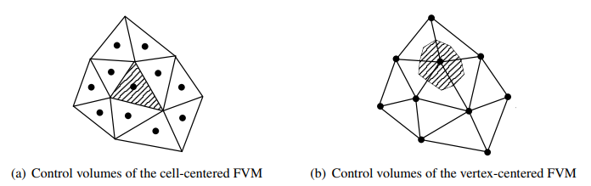

1. Vertex-Cantered Finite Volume Method [8] [9]

Let $Ω⊂R^{2}$ be a polygon and let $T$ be a triangular grid of $Ω$. Denoted by $V_{T}$ be the linear finite element spaces of $H\begin{aligned}1 \\ 0\end{aligned}\left(Ω\right)$ based on $T$:

$$V_{T}=\left\{v∈H\begin{aligned}1 \\ 0\end{aligned}\left(Ω\right):v∨τ∈P_{1}\left(τ\right),∀τ∈T\right\},$$

where $P_{1}\left(τ\right)$ is the linear polynomial space on $τ$. We shall choose $V=V_{T}$. The dimension $N$ is the number of interior vertices of $T$.

The control volume will be given by another mesh $\bar{B}=\left\{b_{i},i=1,···,M\right\}$ satisfying

$$\bar{Ω}=U\begin{aligned}M \\ i=1\end{aligned}bi,∧\overset{˚}{b_{i}}∩\overset{˚}{b_{j}}=∅,i≠j,$$

and to reflect to the Dirichlet boundary condition, we set

$$B=\left\{b_{i}∈\bar{B},b_{i}⊂\overset{˚}{Ω}\right\}.$$

The element $b_{i}$ of $B$ is not necessary to be polygons. But for practical reasons, $b_{i}$ are chosen as polygons such that the boundary integral is easy to evaluate.

Given a triangulation $T$, one construction of $\bar{B}$ is given as follows: for each triangle $τ∈T$, select a point $c_{τ}∈τ$. The point $c_{τ}$ can coincides with middle points of edges.

There are three common choices of $c_{τ}$:

* Type A: $cτ$ is the barycenter of $τ$.
* Type B: $cτ$ is the middle point of the longest edge.
* Type C: $cτ$ is the circumcenter of $τ$.

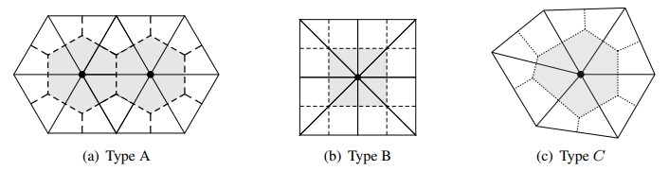

1. DOMAIN DECOMPOSITION Method (DDM)

Domain decomposition methods are iterative methods for the solution of linear or nonlinear systems that use explicit information about the geometry, discretization, and/or partial differential equation (PDE) that gave rise to the (non)linear system.

Domain decomposition methods are parallel, potentially fast, robust algorithms for the solution of the linear (or nonlinear) equations that arise from discretization’s of partial differential equations(PDEs). Some of the motivations for the use of these methods include;

1. Potential for efficient parallelization using data locality,
2. Ability to deal with PDEs on complicated physical geometries,
3. Ability to deal with PDEs that exhibit different behaviour on different parts of the domain (heterogeneous operators), and
4. Superior convergence properties of the iterative method even on sequential machines.

The linear (or nonlinear) systems that arise from the discretization of PDEs inherit many algebraic properties from properties of the underlying PDE. By understanding and using these relationships it is possible to derive fast linear (and nonlinear) solvers.

For linear problems it is customary to view domain decomposition methods as preconditioners for Krylov subspace methods such as the conjugate gradient method or GMRES; see, for instance, the chapter in this volume, Linear System Solvers: Sparse Iterative Methods, by Chan and Van der Vorst. Rather than discuss the theory of preconditioners we simply state that for the solution of the linear system

$$Au=f,$$

the application of a preconditioner B should approximate the action of A-1 well and should be inexpensive (and parallel) to apply.

The most comprehensive reference to domain decomposition methods is Domain Decomposition: Parallel Multilevel Methods for Elliptic Partial Differential Equations, by Smith, Bjorstad, and Gropp, (1995) [10]. A recent eighty-page survey of domain decomposition methods may be found in Chan and Mathew (1994) [11]. Two other limited surveys are on implementation issues by Gropp and Smith (1995) [12] and non-self-adjoint problems by Cai (1994) [13]. The proceedings of the first seven international conferences on domain decomposition methods contain reports on a wide variety of applications and techniques (Chan, Glowinski, et al., 1989, 1990[14], [15]; Keyes, Chan, et al., 1992[16]; Glowinski, Golub, et al., 1988[17]; Glowinski, Kuznetsov, et al., 1991[18]; Quarteroni, Periaux, et al., 1994, Keyes and Xu, 1995) [19].

Domain decomposition algorithms may be applied to a variety of Partial differential equations. To simplify the presentation, however, we restrict attention to linear, second-order, elliptic PDEs,

Lu = f in Ω

Bu = g on $∂$ Ω

A wide variety of discretization’s may be applied. Again, to simplify notations, we assume that the problem is to be discretized with conforming finite elements; finite differences, spectral methods, or finite volume methods may also be used. Domain decomposition methods may be applied equally well on structured or unstructured grids.

The variationally form of the PDE may be written as: find $u∈$ V such that;

a (u, v) = F(v) $∀u∈$ V (1)

Here, a (u, v) is a bilinear form, while F (v) is linear in v. The space V is a suitable function space. For instance, for the homogeneous Dirichlet boundary value problem

$-∇u=f$,

$v=H\begin{aligned}1 \\ 0\end{aligned}\left(Ω\right),$ while $a\left(u,v\right)=\int_{Ω}{∇u∇v∧F\left(v\right)=\int_{Ω}{fv}}$

If we use $\left\{∅_{i}\right\}\begin{aligned}n \\ i=1\end{aligned}$ to denote the finite element basis functions and let $V^{h}=span\left\{∅_{i}\right\}$, then the finite-dimensional variationally (finite element) problem may be given as: find $u^{h}= \sum_{i=1}^{n}{u_{i}∅_{i}}∈V^{h}$ such that

$a\left(u^{h},v^{h}\right)=F\left(v^{h}\right)∀u^{h}∈V^{h}$.

This is equivalent to the linear system

$$Au=f,$$

where

$$A_{ji}=a\left(∅_{i},∅_{j}\right),$$

To motivate the design of domain decomposition methods, we consider the important special case when the operator L is self-adjoint and uniformly elliptic. In this case, the matrix A is symmetric, positive definite and hence defines an inner product ${\left(u,v\right)}_{A}=u^{T}Av$ and a corresponding norm

${\left\|u\right\|}_{A}^{2}=u^{T}Au$.

**Overlapping Methods**

Domain decomposition methods can be broadly classified as either overlapping or nonoverlapping methods. In this section we introduce the key ideas behind overlapping methods.

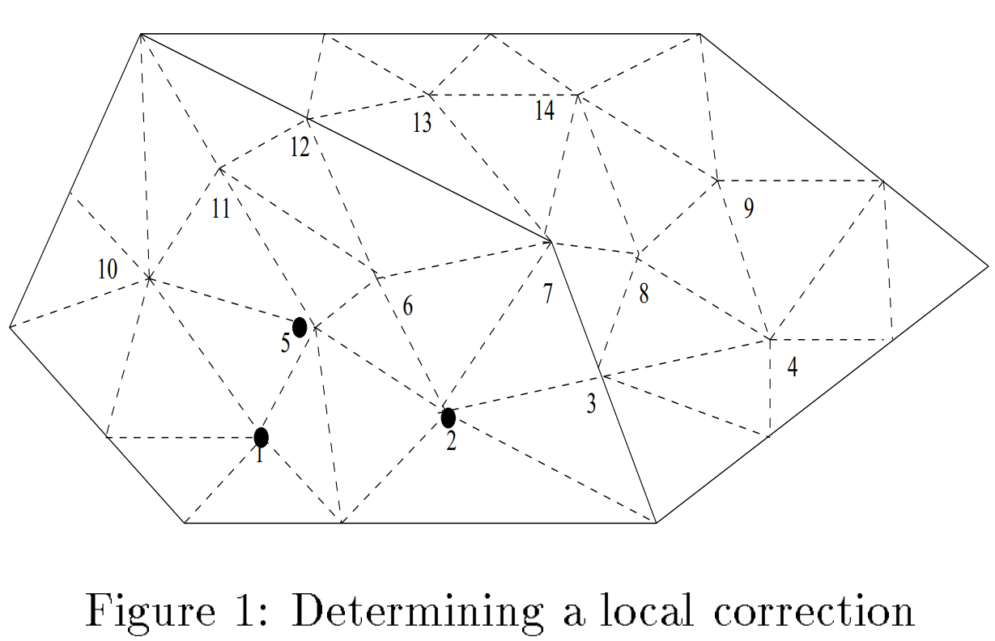

**Figure 1: Determining a local correction**

Consider the domain as depicted in Figure 1, and assume that a second-order, self-adjoint, uniformly elliptic PDE has been discretized by using piecewise linear finite elements on the given grid. If an approximate solution u is known, how may one improve the given solution by adjusting the values on the indicated nodes? To quantify this question, we need to introduce some notation. Let R denote the matrix that when applied to the vector u returns only those values associated with the indicated nodes. For instance, for the nodes 1, 2, and 5, the matrix R is given by

$$R= \left(\begin{matrix}1 & 0 & 0 & 0 & 0 & 0 & … \\ 0 & 1 & 0 & 0 & 0 & 0 & … \\ 0 & 0 & 0 & 0 & 1 & 0 & …\end{matrix} \right)$$

The transpose of R simply inserts the given values into the larger array:

$\left(\begin{aligned}w_{1} \\ w_{2} \\ 0 \\ 0 \\ w_{3} \\ 0 \\ …\end{aligned}\right)$ = $R^{T}\left(\begin{aligned}w_{1} \\ w_{2} \\ w_{3}\end{aligned}\right)$

The matrix R is often referred to as the restriction operator, while RT is the interpolation matrix.

Our “best" local correction is then defined by

$${ _{ w}^{min}\left\|\left.u^{*}-\left(u^{n}+R^{T}w\right)\right\|\right.}_{A}^{2}$$

or, equivalently,

$${ _{ w}^{min}\left(u^{*}-\left(u^{n}+R^{T}w\right)\right)}^{T}A\left(u^{*}-\left(u^{n}+R^{T}w\right)\right).$$

Here $u^{*}$ is the exact solution to the linear system. If we take the derivative with respect to the unknowns w,

$$-RA\left(u^{*}-u^{n}-R^{T}w\right)=0$$

or

$$RAR^{T}w=R\left({Au}^{*}-{Au}^{n}\right).$$

Thus the “local” correction is given by

Correction = ${ R}^{T}w$

$${R^{T}\left(RAR^{T}\right)}^{-1}R\left(f-Au^{n}\right).$$

The matrix RART is simply the sub block of A associated with the given nodes. Hence, the process of extracting out a logical block from the matrix A and solving the reduced linear system with respect to these unknowns is a projection of the error in the A norm. It turns out that, in addition, on the PDE side the computational process may be viewed as a projection of the error onto a subspace of the finite element space $V^{h}$. In the more general case when A is not symmetric, positive definite, the corrections are no longer orthogonal projections of the error. However, they may still have certain desirable qualities.

**Nonoverlapping Methods**

The nonoverlapping domain decomposition methods may also be viewed as combining projections of the error onto subspaces of the solution space. However, there is also a simple linear algebra interpretation, based on a reduced linear system, that we will adopt for this survey.

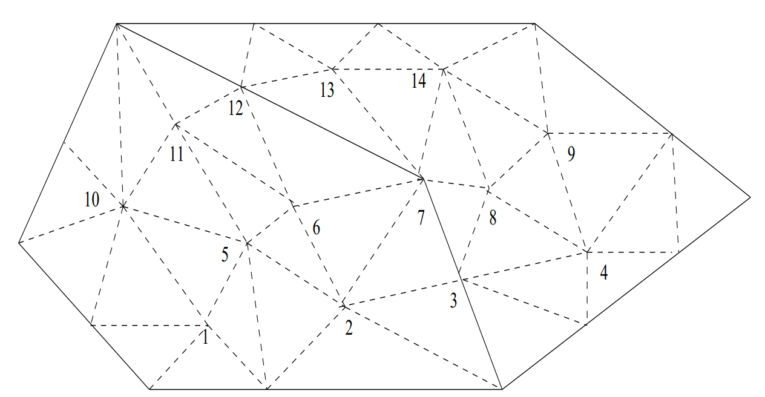

**Figure 2: Two subdomains and an interface**

Consider a domain divided into two nonoverlapping regions as depicted in Figure 3. We partition the unknowns into three sets: those in the first domain (denoted by $\overset{´}{u_{1}}$ and containing nodes 1, 2, 5, 6, 10, 11), those in in the second domain, and those on the interface between the two domains (denoted by $\overset{´}{u_{3}}$ and containing 3, 7, 12). Then the linear system may be written as

$$\left(\begin{aligned}A_{1} \\ 0 \\ A_{31}\end{aligned}\begin{aligned}0 \\ A_{2} \\ A_{32}\end{aligned}\begin{aligned}A_{13} \\ A_{23} \\ A_{3}\end{aligned}\right)\left(\begin{aligned}\overset{´}{u_{1}} \\ \overset{´}{u_{2}} \\ \overset{´}{u_{3}}\end{aligned}\right)=\left(\begin{aligned}f_{1} \\ f_{2} \\ f_{3}\end{aligned}\right)$$

Where

$$A_{3}=A_{3}^{\left(1\right)}+A_{3}^{\left(2\right)}$$

contains contributions from both sides of the interface. The key point is that nodes in the first subdomain are completely decoupled from nodes in the second subdomain. Once the unknowns in $Ω_{1}$ and $Ω_{2}$ have been eliminated, the resulting Schur complement system is given by

${Sü}_{3}={\left(S^{\left(1\right)}+S^{\left(2\right)}\right)}_{ü3}$

$={\left(A_{3}^{\left(1\right)}+A_{31}A_{1}^{-1}A_{13}+A_{3}^{\left(2\right)}-A_{32}A_{2}^{-1}A_{23}\right)}_{ü3}$ $=f_{3}-A_{31}A_{1}^{-1}f_{1}-A_{32}A_{2}^{-1}f_{2}$

$$=g_{3}.$$

This is easily generalized to any number of subdomains.

**Substructuring**

Substructuring is an efficient, parallel direct method for the solution of linear systems arising from discretization of PDEs based on Schur complements. We examine this for a small problem; see Figure 3.

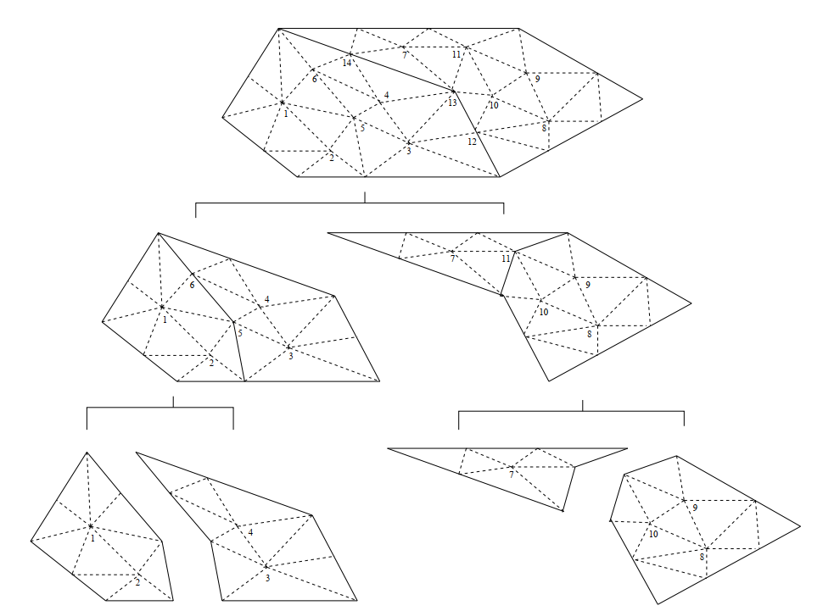

**Figure 3: Example of substructuring**

In this example the elimination is done in three levels.

* Level 1: The four groups 1, 2 and 3, 4 and 7 and 8, 9, 10 are eliminated in parallel.
* Level 2: The two groups 5, 6 and 11 are eliminated in parallel.
* Level 3: The final Schur complement involving 12, 13, 14 is eliminated.

Once the factorization is complete, the unknowns may be calculated.

* Level 3: Solve for u12; u13; u14:
* Level 2: Solve for u5; u6 and u11 in parallel.
* Level 1: Solve for u1; u2 and u3; u4 and u7 and u8; u9; u10 in parallel.

In actual engineering codes much, larger groups of unknowns are usually eliminated in the static condensation process. An introduction to substructuring from the structural engineering point of view may be found in Przemieniecki (1963, 1985) [20] [21]. A modern discussion of the parallelization of a commercial substructuring code may be found in Hvidsten (1990) [22]. The ordering induced by this elimination process is essentially the nested dissection ordering; see George (1973) [23] and George and Liu (1981) [24].

CONCLUSION

We believe that that general notion of computer scientists and engineers are being good at math is a common misconception. So, we tried hard to overcome our fallacies. We not only read some description papers and books of that discretization methods but also tried to understand what fundamentals topics of them and some previous numerical analysis experiments of the authors and a very fun to report them. We did not mention any of the mechanics or industrial concepts because as computer engineer graduate students many of us knows about their importance in the field. Also, we want to present some pure math and its beauty to our colleagues.

We have investigated some discretization methods that FDM, FVM, DDM and have tried to descript as easily as we can. And we tried to implement some of that methods in Python but we could not report the run analysis.

On the other hand, we used to FDM MATLAB implementations to make complexity analysis of these algorithms (Implicit, Explicit, CN). And also we put these codes to our project’s GitHub page.

At last we want to mention that; all these algorithms complexity depends on matrix multiplication complexity. Also, some parallel solving methods are used in industry. If someone reduce the matrix multiplication cost then we believe that solving PDEs are no longer slow.

REFERENCES

[1] By Ebenezer Ampadu A Masters Project Submitted to the Faculty Of WORCESTER POLYTECHNIC INSTITUTE In partial fulfilment of the requirements for the Degree of Professional Master of Science In Financial Mathematics, May 2007

[2] MSc Course in Mathematics and Finance Imperial College London, 2010-11, Mark Davis

[3] New York University Math6911, S08, HM ZHU, Chapter 5

[4] Finite-Difference Approximations to the Heat Equation Gerald W. Recktenwald*,* January 21, 2004

[5] A Review of the Parallel Algorithms for Solving Multidimensional PDE Problems, Norma Alias and Md. Rajibul Islam, 2010

[6] Finite Volume Methods, Chen, 2009

[7] On the finite volume element method for general self-adjoint elliptic problems J. Hu1ang and S. Xi, SIAM J. Numer. Anal., 35(5):1762–1774, 1998

[8] Introduction to the Finite Volumes Method. Application to the Shallow Water Equations, Miguel, Marques, 2008

[9] Finite element methods for flow problems, John Wiley & Sons, Chichester, England. Donea, J. & Huerta, A. (2003)

[10] Smith, Barry F., Bjrstad, Petter, and Gropp, William, 1995. Domain Decomposition: Paral lel Multilevel Methods for El liptic Partial Di erential Equations, Cambridge University Press.

[11] Chan, Tony F. and Mathew, Tarek P., 1994b. “Domain decomposition preconditioners for convection diffusion problems," in A. Quarteroni, J. Periaux, Y. A. Kuznetsov, and O. Widlund, editors, Domain Decomposition Methods in Science and Engineering, pages 157{175, AMS, Providence, RI.

[12] Gropp, William D. and Smith, Barry F., 1995. “Parallel domain decomposition software," in D. Keyes, Y. Saad, and D. Truhlar, editors, Domain-Based Parallelism and Problem Decomposition Methods in Computational Science and Engineering. SIAM, Philadelphia, PA.

[13] Cai, Xiao-Chuan, 1994. “A family of overlapping Schwarz algorithms for non-symmetric and indenite elliptic problems," in D. Keyes, Y. Saad, and D. Truhlar, editors, Domain-Based Parallelism and Problem Decomposition Methods in Computational Science and Engineering. SIAM, Providence, RI.

[14] Chan, Tony, Glowinski, Roland, Periaux, Jacques, and Widlund, Olof, editors, 1989. Domain Decomposition Methods, SIAM, Philadelphia, PA.

[15] Chan, Tony, Glowinski, Roland, Periaux, Jacques, and Widlund, Olof, editors, 1990. Third International Symposium on Domain Decomposition Methods for Partial Differential Equations, SIAM, Philadelphia, PA.

[16] Keyes, David E., Chan, Tony F., Meurant, Gerard A., Scroggs, Jeffrey S., and Voigt, Robert G., editors, 1992. Fifth International Symposium on Domain Decomposition Methods for Partial Differential Equations, SIAM, Philadelphi, PA.

[17] Glowinski, Roland, Golub, Gene H., Meurant, Gerard A., and Periaux, Jacques, editors, 1988. Domain Decomposition Methods for Partial Differential Equations, SIAM, Philadelphia, PA.

[18] Glowinski, Roland, Kuznetsov, Yuri A., Meurant, Gerard A., Periaux, Jacques, and Widlund, Olof, editors, 1991. Fourth International Symposium on Domain Decomposition Methods for Partial Differential Equations, SIAM, Philadelphia, PA.

[19] Quarteroni, Al o, Periaux, Jacques, Kuznetsov, Yuri A., and Widlund, Olof B., editors, 1994. Domain Decomposition Methods in Science and Engineering, AMS, Providence, RI.

[20] Przemieniecki, J. S., 1963. \Matrix structural analysis of substructures," Am. Inst. Aero. Astro. J. 1, pages 138{147.

[21] Przemieniecki, J. S., 1985. Theory of Matrix Structural Analysis, Dover Publications, Inc., New York. Reprint of McGraw-Hill, 1968.

[22] Hvidsten, Anders, 1990. On the parallelization of a finite element structural analysis program," Technical report, University of Bergen, Norway. Ph.D. thesis. Computer Science Department

[23] George, Alan, 1973. Nested dissection of a regular finite element mesh," SIAM J. Numer. Anal. 10, pages 345-363.

[24] George, Alan and Liu, Joseph, 1981. Computer Solution of Large Sparse Positive Definite Systems, Prentice-Hall, Englewood Cliffs, NJ.